|  |  |  |  |
| --- | --- | --- | --- |
| **SVKM's-IOT, Dhule**Shri Vile Parle Kelavani Mandal's  **INSTITUTE OF TECHNOLOGY**  **DHULE (M.S.)**  **DEPARMENT OF COMPUTER ENGINEERING** | | | |
| **Subject :** Java Programming Lab (Seminar-I) | | | Remark |
| **Name :**  Ansari Asharul Ameen Naeem Ahmad | | **Roll No. :** 63 |
| **Class:** SY. Comp. Engg. | **Batch : S4** | **Division: A** |
| **Expt. No. :**07 | **Date :** | | Signature |
| **Title :**   **Write Java Programs on Inheritance** | | |
|  | | |
|  | | |

**//program 1 :**

// single inheritance

class A { void show() {

System.out.println("I am in A class");

}

}

Class B

extends A { void show1() {

System.out.println("I am in B class");

}

public static void main(String[] args) {

B obj = new B();

obj.show();

obj.show1();

}

}

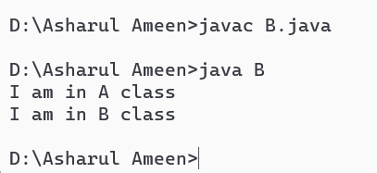

**// program 2:**

// multilevel inheritance

class A { void showA() {

System.out.println("I am in class A");

}

}

class B extends A { // B inherits A

void showB() {

System.out.println("I am in class B");

}

}

class C extends B { // C inherits B (and indirectly A)

void showC() {

System.out.println("I am in class C");

}

}

public class MultilevelExample {

public static void main(String[] args) {

C obj = new C();

obj.showA();

obj.showC();

}

}

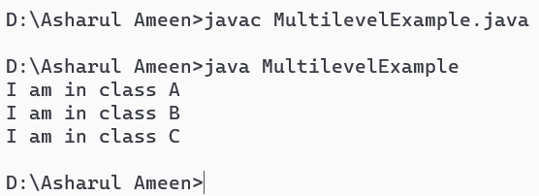

// hybrid interface

A { void showA();

}

class B { void showB() {

System.out.println("I am in class B");

}

}

class C extends B implements A {

public void showA() {

System.out.println("I am in class A");

}

void showC() {

System.out.println("I am in class C");

}

}

public class HybridExample { public static void main(String[] args) {

C obj = new C();

obj.showA();

obj.showB();

obj.showC();

}

}

